Report

Q. 1) Find all the unique 'Wind Speed' values in the data.

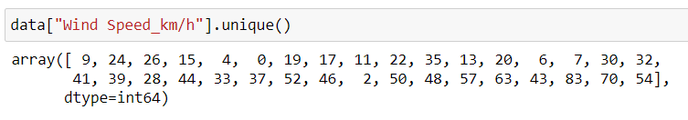

We use .unique( ) method to find out all the unique values in a column.

Q. 2) Find the number of times when the 'Weather is exactly Clear'.

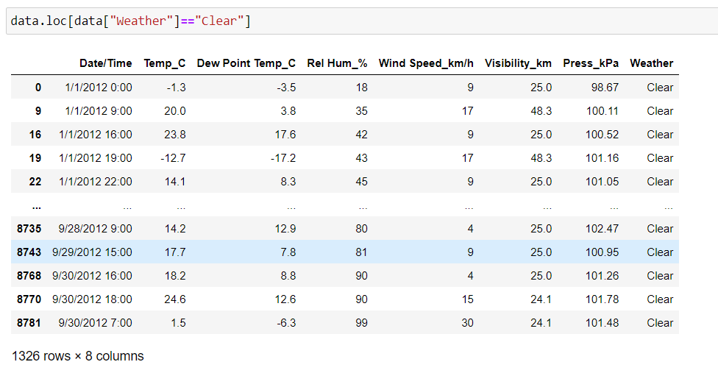

The number of times when the weather is clear is 1326.

Q. 3) Find the number of times when the 'Wind Speed was exactly 4 km/h'.

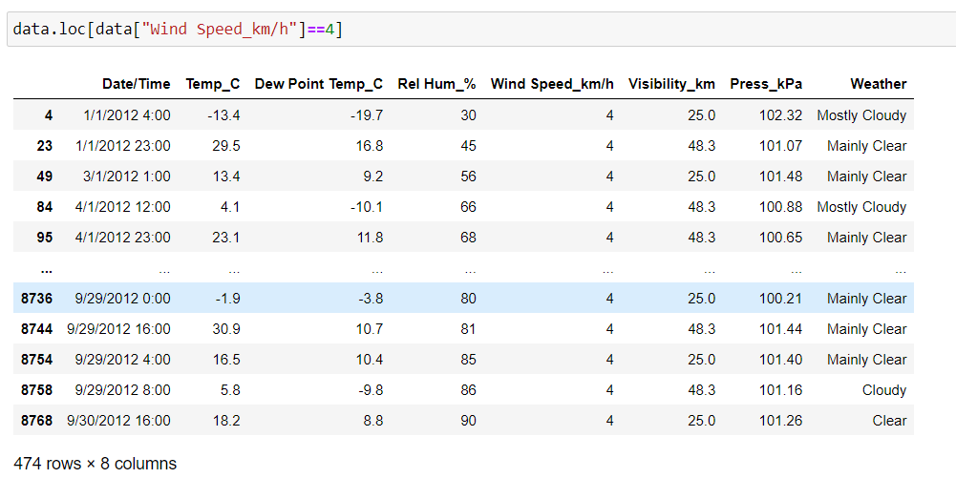

The number of times when the wind speed was exactly 4 kmph is 474.

Q. 4) Find out all the Null Values in the data.

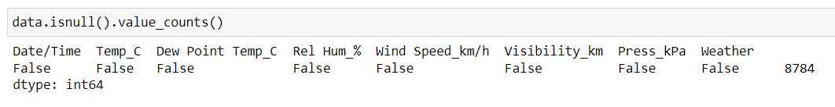

Here false means that there are no null values in the data.

Q. 5) Rename the column name 'Weather' of the dataframe to 'Weather Condition'.



We use rename command to rename a certain column name with another name. We use inplace=True to permanently apply the change.

Q. 6) What is the mean 'Visibility' ?

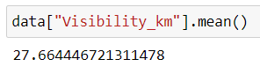

To get mean of visibility column we accessed it first and then applied .mean( ) on it.

Mean of visibility column is 27.6 .

Q. 7) What is the Standard Deviation of 'Pressure' in this data?

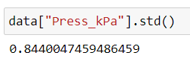

Std( ) is the function used to find out standard deviation.

The standard deviation of pressure column in the data is 0.84 .

Q. 8) What is the Variance of 'Relative Humidity' in this data ?

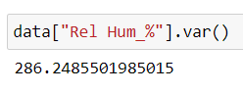

Var( ) is the function used to find out variance. Variance of Relative humidity is 286.24 .

Q. 9) Find all instances when 'Snow' was recorded.

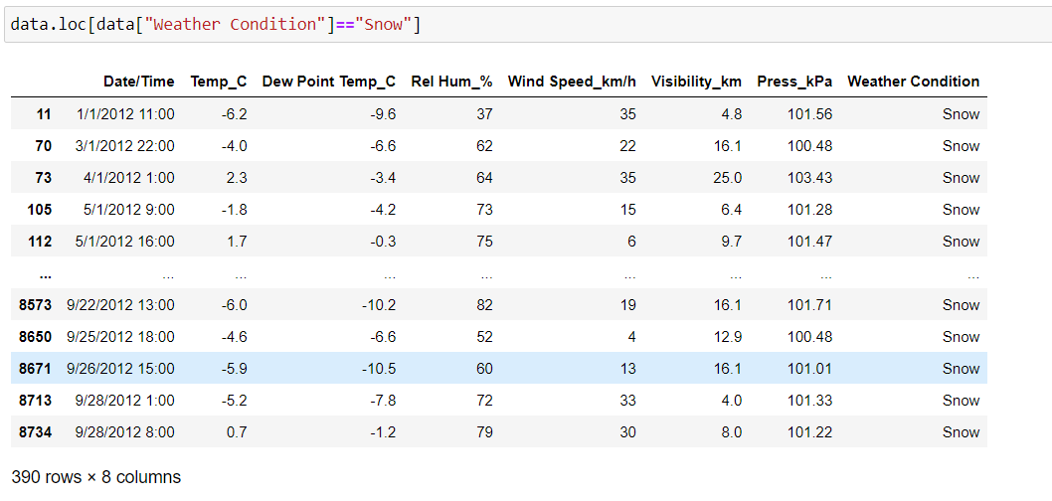

These are all the instances where snow was recorded. There are 390 instances when snow was recorded.

Q. 10) Find all instances when 'Wind Speed is above 24' and 'Visibility is 25'.

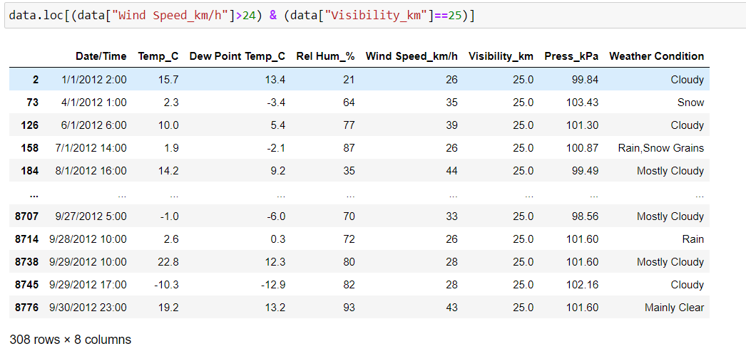

These are the instances where wind speed is greater than 24 and visibility is 25. There are total of 308 instances.

Q. 11) What is the Mean value of each column against each 'Weather Condition ?

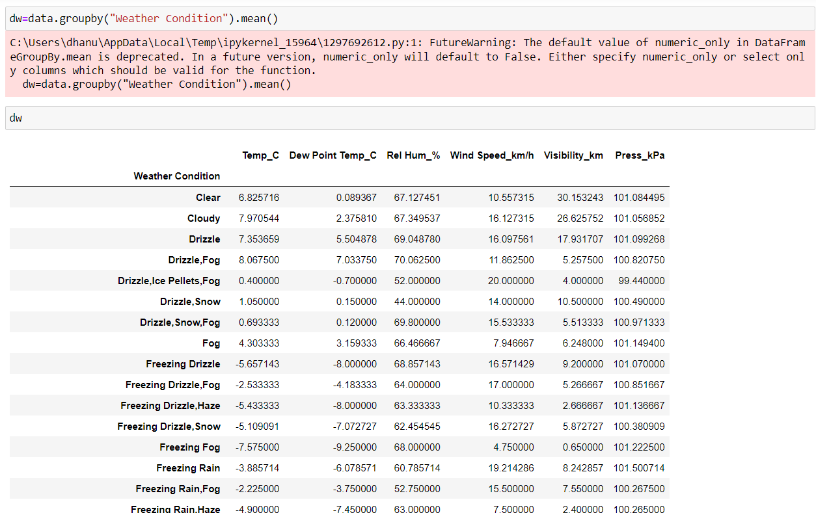

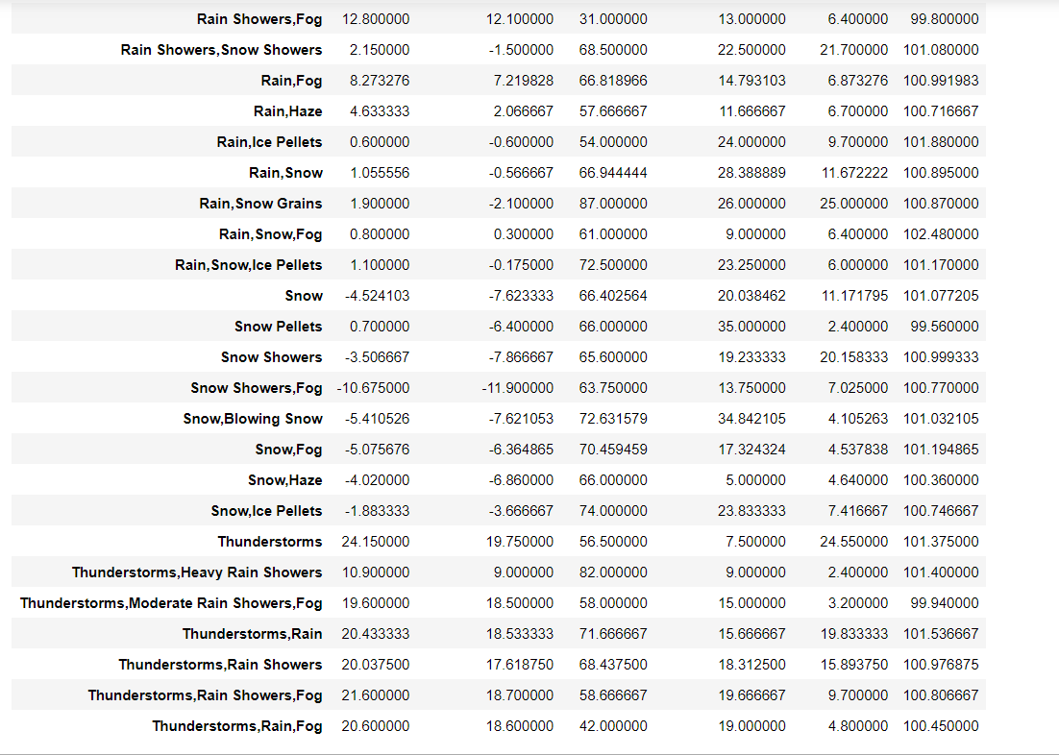

We have used group by function to divide each weather condition into a group. After dividing into groups we applied .mean( ) function to find out mean values of each group.

Q. 12) What is the Minimum & Maximum value of each column against each 'Weather Condition ?

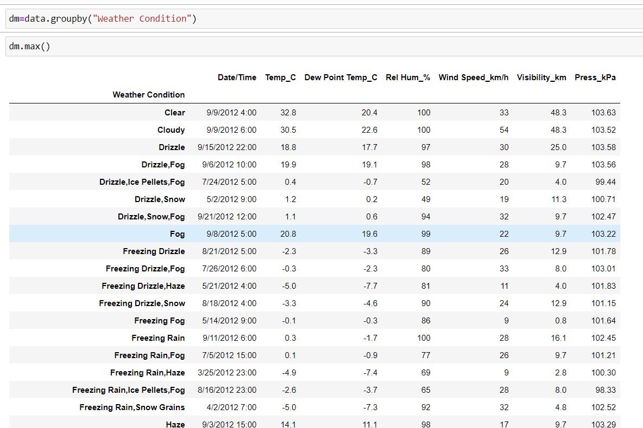

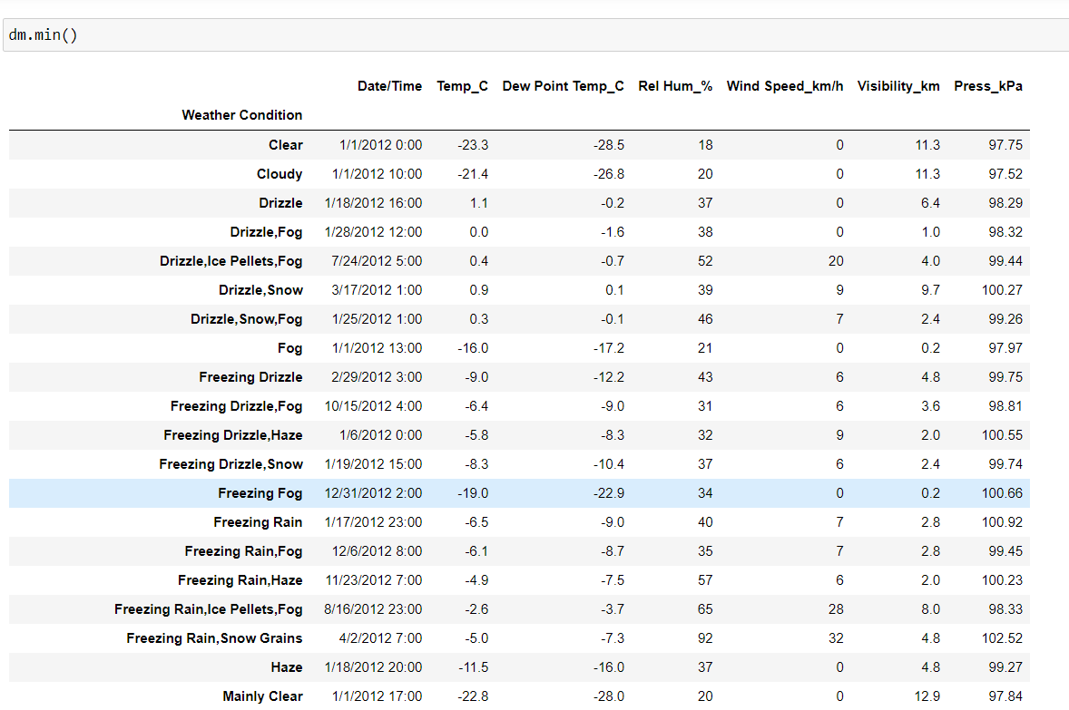

As in previous question we used group by and separated them based on weather conditions. After dividing we have applied .min(), .max() functions on those groups.

Q. 13) Show all the Records where Weather Condition is Fog.

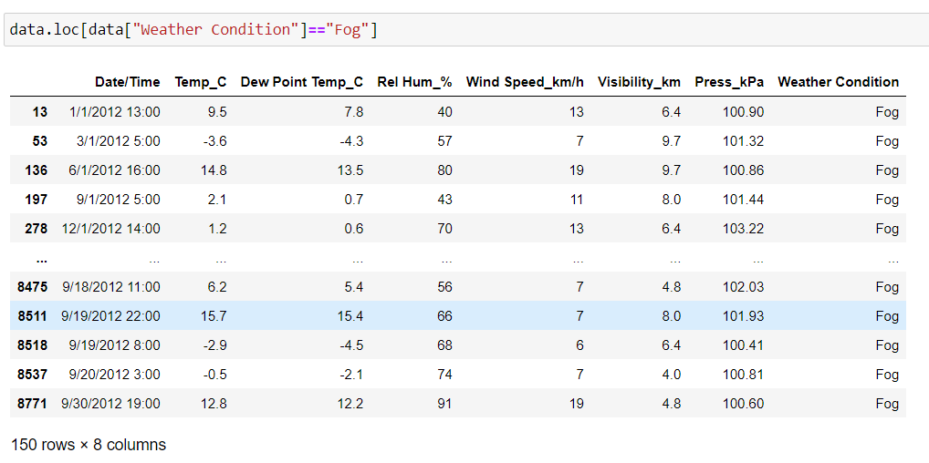

These are all the records where weather condition is fog. There are 150 records.

Q. 14) Find all instances when 'Weather is Clear' or 'Visibility is above 40'.

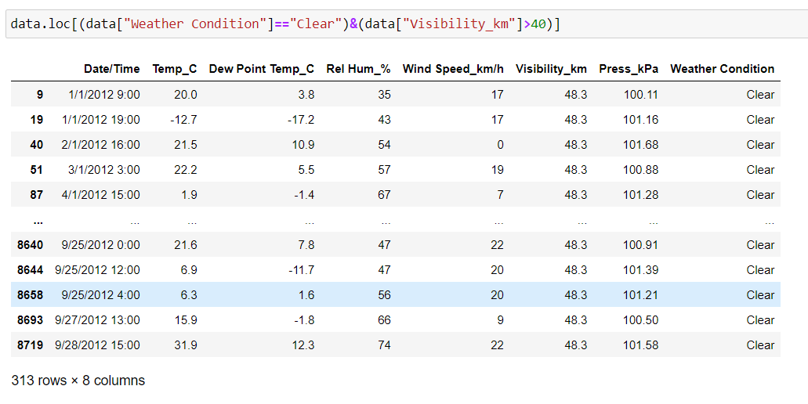

These are the instances where the given conditions are satisfied. There are 313 instances.

Q. 15) Find all instances when :

A. 'Weather is Clear' and 'Relative Humidity is greater than 50'

or

B. 'Visibility is above 40'

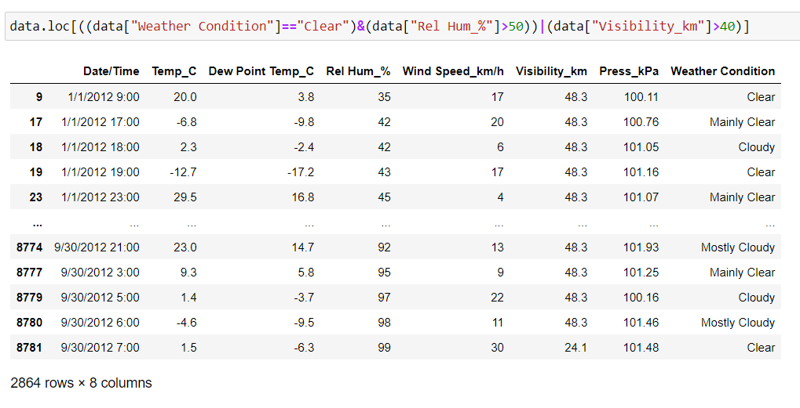

Here we used bitwise operators to check for 3 conditions (&,|).